**Situation analysis – Coopers Brewery**

**Coopers**

The coopers brew of beer dates back to the first European settlers of Australia. The settlers preferred imported beer from back home in England so in 1862 Thomas Cooper then decided to brew a beer from all natural resources and the best ingredients possible. The company brews a wide range of beers from pale ales to stouts to pilsners. Coopers have a rich history in beer but over the last couple of decades their brand has declined in Australia’s beer scene. The implementation of a new marketing campaign or new product could be the answer to brining Coopers back to where they were during the mid to late 90’s.

**Coopers organisation**

Coopers Brewery Limited is Australia’s largest beer corporation currently producing over 20 different types of beer and is the father company to such beers as Carlsberg, Thatcher’s Gold, Sapporo and many more. The company has been in business for an estimated 154 years and has always been a family run business. During 2015 Coopers Brewery had 218 active employees in Australia all subsidiaries of Coopers brand are included. The Brewery was first started in Leabrook, South Australia, since the brewery has moved to Regency Park which is approximately five kilometers outside of Adelaide’s CBD. Today Coopers holds just under four percent (3.8%) of Australia’s beer market at the end of the 2014/15 financial year. According to the Chairman and Managing Director of Coopers Brewery “Revenue for 2014-15 of $235.1 million rose from $231.3 million last year. After tax, profit increased by 3.2% to $28.9 million, from $28.0 million last year” (Coopers, 2015, p. 6).

**Australian market**

The Australian beer market peaked in the 1970’s since then beer has been on a constant decline per capita. Figure 1 is a representation of the consumption of pure alcohol in types of beverage.

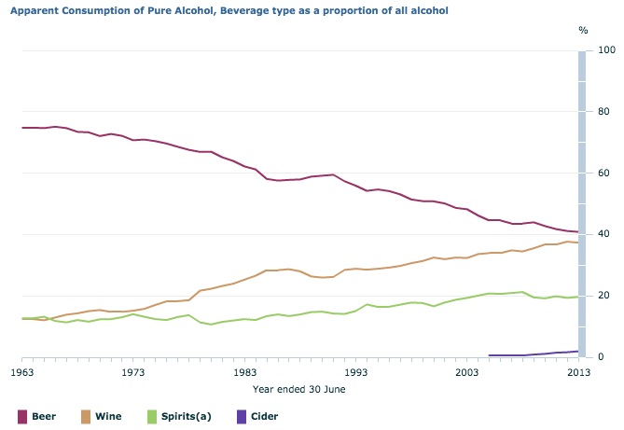

*Figure 1. (Rodriguez, A, 05.11.15)*

According to the National Bureau of statistics Australian’s have started prefer to drink imported beer from overseas and alcoholic beverages with a higher alcohol content such as wine and spirits. Rodriguez (5.11.15) reports on the beer market "The beer market is declining because Australians are have shifted interest in alcoholic beverages to more expensive higher alcohol contented beverages such as wine and spirits”. As Australia’s interest shifts to drinking higher alcohol content beverages and maintaining a healthy lifestyle rise, there becomes increasing uncertainty in the Australia’s beer industry. International beer is becoming increasingly prominent in Australia. Table 1 shows the top 10 leading competitors in the Australia’s national beer market and their share of the market by total

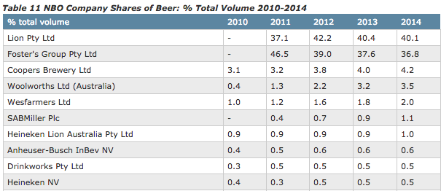volume.

Table 1

**Macro-Environment Analysis**

PESTLE Analysis: Coopers

|  |  |
| --- | --- |
| Political/Legal | * Legislations and codes governing company procedures;   + Advertisement/marketing   + Distribution   + Trading * Liquor Act 1992 * Alcoholic Beverages Advertising Code (ABAC) * Corporations Act 2001 |
| Economic | * Declining market * Changing liquor scene |
| Social | * Australian’s starting to drink higher alcohol content beverages * Increase in healthy lifestyle   + Less alcohol consumption * International beer becoming very popular * Spirits and pre mix drinks on rise * Craft beer on rise |
| Technological | * Advances in technology has seen the creation of re-sealable cans in Germany over the last couple of years * Advances in packaging and * This advance has not yet made it to Australia |
| Environmental | * Big emphasis on ‘going green’ and saving the environment * Hard for beer companies to go green has they use a lot of mechanical machines that cause pollution |

**SWOT Analysis – Coopers Brewery Ltd**

|  |  |  |
| --- | --- | --- |
|  | Favorable | Unfavorable |
| Internal | Strengths | Weaknesses |
| * Large brewing capacity * Solid customer base * Well known * Solid market share * Good profit and turn over * Interchangeable personnel * Part of a huge network | * Unappealing label * No recent marketing campaign * Hard to change product   + Must go through numerous parties to bring out new product * Hard to control quality because it is a very large globally trading company |
| External | Opportunities | Threats |
| * Introduce a new product or campaign * Use profit to develop better label * Use profit to develop new marketing campaign * Opportunity to buy out smaller companies in order to further growth * Social mwe | * Rise of craft beer * Rise of international beer * Decreasing market * Larger international businesses controlling Australian market share   + SABMiller   + Lion Pty Ltd |

**Reference List:**

Brewers Association of Australia and New Zealand (n.d.). Our view (n.d.). <http://www.brewers.org.au/our-views/alcohol-consumption-in-australia/>

Cooper. T. Cooper. G. Coopers Brewery Limited. (1862). Coopers Annual Report (2015). Retrieved from <http://www.coopers.com.au/static/media/uploads/coopers_annual_report_2015.pdf>,

Rodriguez. A (2015, November 5). Beer consumption in Australia is falling at a remarkable pace. Quartz. Retrieved from <http://qz.com/542231/beer-consumption-in-australia-is-falling-at-a-remarkable-pace/>

IBISWorld. (n.d.). Coopers Brewery Limited – Premium Company Report Australia. Retrieved from <http://www.ibisworld.com.au/car/default.aspx?entid=1489>

Passport. (2015, September). Analysis: Beer in Australia. Retrieved from <http://www.portal.euromonitor.com.libraryproxy.griffith.edu.au/portal/analysis/related>

National Measurement Institute. (2010). Guide to the Sale of Alcohol (n.d.)

Liquor Act 1992

Australian Bureau of Statistics. (2013). Alcohol Consumption

Advertising Standards Bureau. Alcohol Advertising. (n.d.) Retrieved from <https://adstandards.com.au/products-issues/alcohol-advertising>

Alcohol Beverage Advertising Code. Responsible Marketing of Alcohol. (2013). (n.d.)

Dunphy, J. (2014). Crown Discuss Three Major Can Technologies Changing The Craft Industry. Retrieved from <http://www.craftbrewingbusiness.com/packaging-distribution/craft-beer-can-technology/>